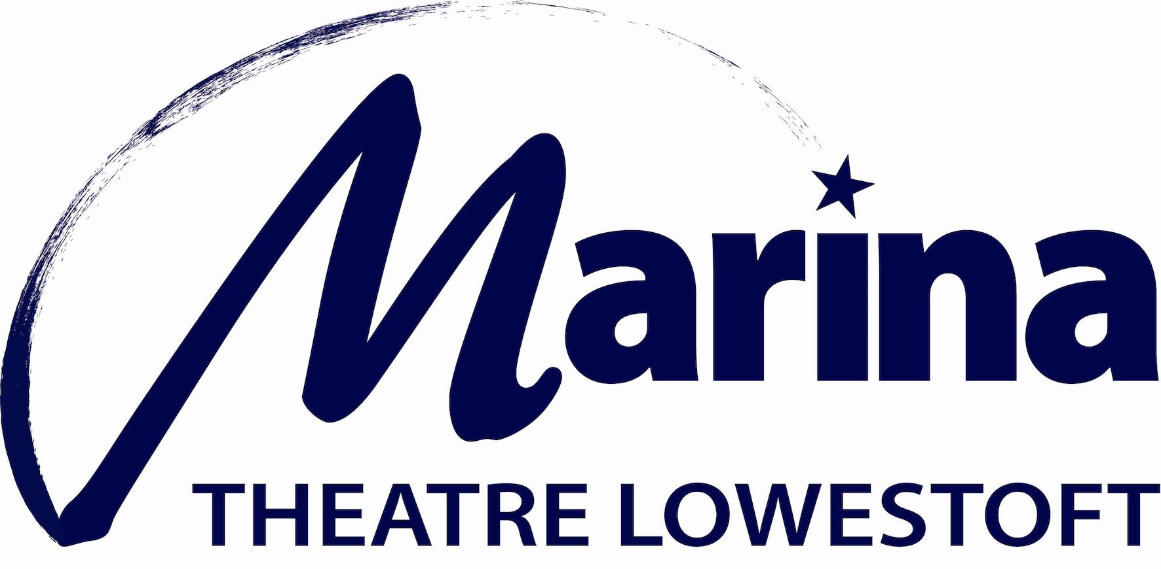

Equal Opportunities Monitoring Form

The Marina Theatre Trust strives to operate a policy of equal opportunity and not discriminate against any person. This includes adhering to the Equality Act 2010, and building an accurate picture of the make-up of our workforce in encouraging equality and diversity.

We need your help and co-operation to help us monitor our effectiveness as an equal opportunities employer, but filling in this form is voluntary. Please return this form as a separate attachment to your application.

This information will only be used for monitoring purposes and is separated from your application at the point of receipt.

Disability

Do you consider yourself to have a disability? Yes/No
If Yes, are you registered disabled? Yes/No
Prefer not say

Gender

Male Female Non-binary Prefer not to say
If your own term is not listed, please specify here …………………….

Marriage/Civil partnership status

Are you married or in a civil partnership? Yes No Prefer not to say

Sexual Orientation

Heterosexual Gay woman/lesbian Gay man Bisexual
Prefer not to say
If you prefer to use your own term, please specify here ……………………………………………….….

Age

Under 21 31-40 51 - 65
21 – 30 41-50 Over 65

Religion/belief

What is your religion or belief?

No religion or belief Buddhist Christian Hindu Jewish Muslim Sikh
Prefer not to say
If other religion or belief, please specify her………………………………………..

Working patterns

What is your current working pattern?

None Flexi-time Staggered hours Term-time hours Annualised hours Job-share
Flexible shifts Compressed hours Homeworking Prefer not to say
If other, please specify here……………………………………………

Caring responsibilities

Do you have any caring responsibilities?

None Primary carer of a child/children (under 18) Primary carer of disabled child/children
Primary carer of disabled adult (18 and over) Primary carer of older person
Secondary carer (another person carries out the main caring role)
Prefer not to say

Ethnic Origin & Cultural Background

How would you describe your ethnic origin?

Choose ONE Section A to F, then tick the appropriate boxes to indicate your cultural background.

A White

English Irish
Scottish Welsh
Any other White background, please specify in

B Mixed / Multiple Ethnic Groups

Mixed English White & Black Caribbean
Mixed Scottish White & Black African
Mixed Welsh White & Asian
Any other Mixed background, please specify in

C Asian / Asian British

Asian English Indian
Asian Scottish Pakistani
Asian Welsh Bangladeshi
Any other Asian background, please specify in

D Black / African / Caribbean / Black British

Black English Caribbean
Black Scottish African
Black Welsh
Any other Black background, please specify in

E Chinese / Chinese British

Chinese English Chinese Welsh
Chinese Scottish Chinese
Any other background, please specify in

F Other ethnic group

Prefer not to say
Any other background, please specify in

March 2021

